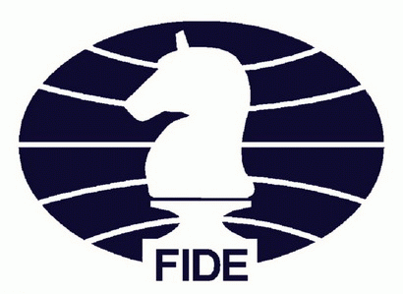

FIDE World Rapid and Blitz Championships &

FIDE Women’s World Rapid and Blitz Championships

Samarkand, 2023

DRESS CODE

I. FIDE Dress Code Policy

**1. Dress to Impress.**

Help CHESS by wearing proper attire. It is important to promote a good and positive image of chess. Attire worn during all phases of the Championships should be in good taste and appropriate for such a prestigious chess event.  
  
**2. Who is affected by the Dress Code?**  
A. Participating players;

B. FIDE Principals, arbiters and staff (unless a uniform is provided for them by FIDE);

C. FIDE Officials and representatives attending the event.  
  
II. Dress Code Requirements  
  
**1. The required dress-code for the playing venue is Smart Business Attire.**  
   
A. The following is **acceptable** for men:

suits, ties, trousers, long-sleeve or short-sleeve shirt, alternatively long-sleeve or short-sleeve polo-shirts, shoes, loafers, jacket, vest or sweater, national traditional dress (the latter shall be approved by the FIDE Technical Delegate in advance).  
  
B. The following is **NOT acceptable** for men:   
sports sneakers, T-shirts, any kind of jeans, any kind of inappropriate cloth (e.g. torn cloth or cloth with holes, unclean cloth), sport caps, sun glasses.  
   
C. The following is **acceptable** for women:  
women's suits, dresses, skirts, blouses, turtleneck, T-shirts or polos, trousers or slacks, jacket, vest or sweater, scarf, footwear (boots, flats, mid-heel or high heel shoes), as well as jewelry (earrings, necklace, etc.), national costumes clothing (the latter shall be approved by the FIDE Technical Delegate in advance).   
  
D. The following is **NOT acceptable** for women:  
sport’s sneakers, clacking shoes, any kind of jeans, any kind of inappropriate cloth (e.g. torn cloth or cloth with holes, unclean cloth), sport caps, sun glasses, revealing attire.

**2. There is no dress code requirement for any function outside the playing venue.**

III. Handling Dress Code Violations

**1. The dress code shall be strictly enforced.**  
  
A. The Chief Arbiter (after consultation with two representatives of Fide Athletes Commission if required) is entitled to decide whether the dress code requirements are respected by each player and apply sanctions in accordance with Articles III.1.B and C below.  
  
B. For each player, the first infringement* shall result in financial penalty of:

- 200 € in any of open events;

- 100 € in any of women’s events;

The sanctioned player shall be allowed to play the current round.

C. For each player, the further infringements* shall result in not being included in the pairings for the next round*.

*Each round counts as one infringement. The next round is deemed to have started when its pairings are published.